CHAPTER 1
INTRODUCTION

Resumes are commonly presented in PDF or MS word format, and there is no particular structured format to present/create a resume. So, we can say that each individual would have created a different structure while preparing their resumes. It is easy for us human beings to read and understand those unstructured or rather differently structured data because of our experiences and understanding, but machines don’t work that way. Machines cannot interpret it as easily as we can. The conversion of cv/resume into formatted text or structured information to make it easy for review, analysis, and understanding is an essential requirement where we have to deal with lots of data. Basically, taking an unstructured resume/cv as an input and providing structured output information is known as resume parsing.
Subsequently, converting a resume into prepared text or structured information makes studying, analyzing, and comprehending easier. As a result, many organizations and institutions depend on Information Extraction, where unstructured data and vital information are extracted and converted to make information more readable and organized data forms. The completion of this task takes a long time for humans. So, it is necessary to develop an automated intelligent system that can extract all relevant information to determine whether an applicant is suitable for a particular job profile.
Resume parser is an NLP model that can extract information like Skill, University, Degree, Name, Phone, Designation, Email, other Social media links, Nationality, etc. irrespective of their structure. To create such an NLP model that can extract various information from resume, we have to train it on a proper dataset. And we all know, creating a dataset is difficult if we go for manual tagging. To reduce the required time for creating a dataset, we have used various techniques and libraries in python, which helped us identifying required information from resume.
Email address and Phone number are well-defined patterns in themselves. Thus we would be using Regular Expressions in order to capture them in the resume. This may seem easy but in reality one of the most challenging tasks of resume parsing is to extract the person’s name. There are millions of names around the world and living in a globalized world, we may come up with a resume from anywhere.
For extracting the skills we collected the top 50 skills and using spacy matcher we mapped each word from the text with 50 skills so the words which match the condition can belong to the skills category. This technique helps us to find the skills from the resume.

CHAPTER 2
LITERATURE SURVEY

Agencies and different high-level companies have to deal with an extreme number of new jobs seeking employees with different resumes. However, looking after those large numbers of text data and filtering out the needed candidates is a burden on the brain and more time consuming. Therefore, the essence of this literature review is on studying resumes in different formats such as single-column resumes, double-column resumes with extension.pdf,.docx, and how the suggested Information Extraction System converts that unstructured information into structured layout through Parsing. Accordingly, this review also helps to understand and apply several in-use and well recognized algorithms currently being used in industries to reduce human labor. Depending upon the Company's preference to hire employees, the Extraction System will manage the gathered information with more readability and organized data forms. Furthermore, the analysis of various machine learning algorithms and natural language processing techniques would be equally carried out along with their proper implementation and evaluation. The reviews from multiple research publications and journals are included below.

The use of two natural language processing algorithms to extract important data from an unstructured multilingual CV has provided a solution for selecting relevant document parts and the similar particular information at the low hierarchy level (VUKADIN, et al., 2021). It uses a machine learning method in NLP to obtain a high level of extraction accuracy. The authors claim that they have solved the CV parsing challenge by building an NLP system. The recently introduced tokens [NEW LINE] and [SKILL] are shown to have trained to perform as expected.

Recruitment has evolved rapidly in the last decade, from traditional job fairs to web-based recruitment platforms. As a result, (Wang & Zu, 2019) presented a resume parsing pipeline that uses neural network-based classifiers and distributed embeddings from beginning to end. The pipeline eliminates the laborious process of manually creating several handcrafted elements.
( Kopparapu, 2015)proposes a natural language processing (NLP) system that focuses on automated information extraction from resume to facilitate speedy resume search and management for structured and unstructured resumes. The reviewed literature addressed a wide range of information extraction concepts and research-based procedures and their main approaches. The majority of the research material uses a combination of ML and DL-based methods. After analyzing all of the review findings, it is easier to conclude that extracting meaningful information from resumes using NLP and its different techniques like Regex and Spacy simplifies the recruiting process significantly minimizes time complexity in a larger way.

CHAPTER 3
SYSTEM ANALYSIS

3.1 Natural Language Processing
Natural language processing is a branch of artificial intelligence and computational linguistics. It can be defined as the process which is involved in the interaction between a computer and natural language i.e the language, spoken by humans. It is directly related to the field of human-computer interaction. Now that natural language processing is properly defined, we will be using the following constraints of NLP to parse the information from the resumes:
3.1.1 Lexical Analysis
The pilot stage of the compiler is lexical analysis. The altered source code is taken from the language preprocessor which writes in the form of sentences. The analyzer removes any comments or whitespace from the source code, breaking these syntaxes into a chain of tokens.
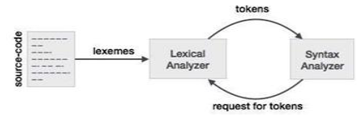
FIGURE 3.1 Lexical Analysis

Considering our case, the resume is discriminated onto various segments including contact information, educational experiences, work experiences and more. We use a database or a data dictionary to hold the keywords or headings we find common in most of the resumes.

Now when a new resume is taken, the parser searches for the keywords and extracts all the data between the starting and the ending of them, which we call as segments. Out of the many exceptions which might occur, one which is common is that the first segment generally contains the name as well as the contact information of the person. Now we program chunkers or Named Entity Recognizer to extract data from each segment specifically. This method makes the system efficient and reduces its complexity. Now if due to some reason the recognizer runs on a wrong piece of data, the system will produce unexpected results.

3.1.2 Syntactic Analysis
The syntactic analysis determines the structure of data. The architecture comprises of a hierarchy of expressions, the smallest being a basic symbol and the largest being sentences. We can visualise the architecture as a tree whose nodes represents the expressions. Values stored in the nodes represent the basic symbols. The root represents the sentence.

Parse Tree:
The parse tree is generated by the parser with syntactic analysis. A parse tree or a parsing tree is an organized , entrenched structure which we use to represent the syntactic analysis of a string. They categorically reflect the syntax of the input data, making them noticeable from the abstract syntax trees used in programming.

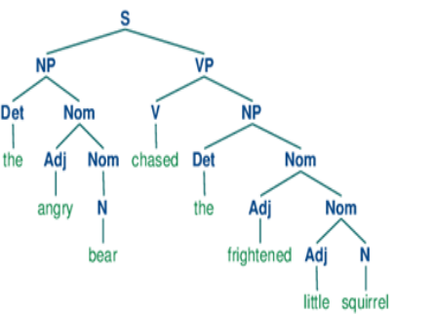

FIGURE 3.2 PARSE TREE REPRESENTING SYNTACTIC ANALYSIS

3.1.3 SEMANTIC ANALYSIS
Semantic analysis can be defined as the study of semantics i.e the structure and meaning of speech. This process relates syntactic structure to the level of the writing as a whole from the levels of clauses, phrases, paragraph and sentences. It relates to their language-independent meanings. Let's take an example. Person A has a resume which states he has graduated from the "University of Calcutta" and person B has a resume which says he has graduated from "Calcutta University". Essentially they both graduated from the same place. So what semantic analyzer does is convert "University of Calcutta" to "Calcutta University". In Information Retrieval research, text classification system is given the utmost focus which bounds the decisions to either relevant or non-relevant depending upon the information need of the user. It is not a hard task to get the user information need.

3.2 Existing System

In parsing the resume at first manually we collect the resumes from different category It takes more time to collect the each category resumes. Based upon the experience of the particular candidate we select the resume for next process but it is much hard to check all the details particularly of each resume .To overcome this process we develop the resume parsing project using NLP techniques and machine learning models .

3.2.1 Disadvantages
People with diverse personalities come from a variety of fields and backgrounds. In the same way, their resume writing style varies. They've worked on a variety of projects, and each of them has unique writing style. As a result, each resume is unique. Takes more time to specify category of resume. Manually it is hard to find skills and other required information from each resume.
Some people work in the human resources department. They will have to go through hundreds of resumes on the internet. Executives summarize the resume, enter specific information into their database, and then call the applicant for job counselling after obtaining the resume. An executive spent around 10-15 minutes on each resume, summarizing it and entering the information into the database. This project will help in the automation of this procedure.

  - Proposed System

The main objective of Natural Language Processing (NLP)-based Resume Parser using nlp project is to extract the required information about candidates without having to go through each and every resume manually, which ultimately leads to a more time and energy-efficient process.
Resumes are commonly presented in PDF or MS word format, And there is no particular structured format to present a resume. So , by using this project we can convert the resume to a structured format.

A purpose system can help in resolving the challenge of obtaining useful information from a resume in a structured format. By resolving this issue, recruiters will be able to save hours each day by eliminating manual resume screening. Bias in hiring is still prevalent, thus this method may also address the bias hiring process and strengthen a non-bias policy.

Purpose system is not able to solve the complex network issue such as:
• Excessive web traffic can significantly slow down or restrict access to a website entirely. This occurs when the server receives more file requests than it can handle.

3.4 system Requirements

3.4.1 Hardware Requirements

Processor : Intel I5
Speed : 1.6 Ghz
RAM : 6GB (min)
Hard Disk : 500 GB

3.4.2 Software Requirements

Language : Python 3.9
Operating System : OS Independent
IDE : Jupyter notebook

CHAPTER 4
SYSTEM DESIGN

4.1 System Architecture

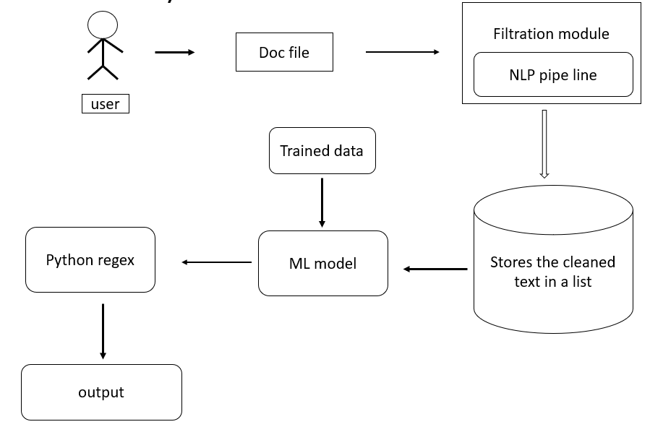

Fig 4.1: System Architecture

4.2 Dataflow Diagram
A data flow diagram (DFD) maps out the flow of information for any process or system. It uses defined symbols like rectangles, circles and arrows, plus short text labels, to show data inputs, outputs, storage points and the routes between each destination. Data flowcharts can range from simple, even hand-drawn process overviews, to in-depth, multi-level DFDs that dig progressively deeper into how the data is handled. They can be used to analyse an existing system or model a new one. Like all the best diagrams and charts, a DFD can often visually “say” things that would be hard to explain in words, and they work for both technical and nontechnical audiences, from developer to CEO. That is why DFDs remain so popular after all these years.
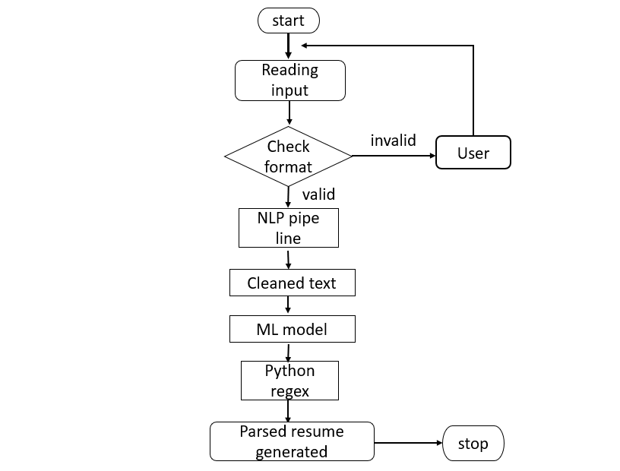
Fig 4.2 Dataflow Diagram

4.3 UML Diagrams
Unified Modeling Language:
Unified Modeling Language, is a standardized modeling language consisting of an integrated set of diagrams, developed to help system and software developers for specifying, visualizing, constructing, and documenting the artifacts of software systems, as well as for business modeling and other non-software systems. The UML represents a collection of best engineering practices that have proven successful in the modeling of large and complex systems. The UML is a very important part of developing object oriented software and the software development process. The UML uses mostly graphical notations to express the design of software projects.
Using the UML helps project teams communicate, explore potential designs, and validate the architectural design of the software. The goal of UML is to provide a standard notation that can be used by all object-oriented methods and to select and integrate the best elements of precursor notations. UML has been designed for a broad range of applications. Hence, it provides constructs for a broad range of systems and activities (e.g., distributed systems, analysis, system design and deployment).

4.3.1 Use case Diagram
A use case diagram is used to represent the dynamic behaviour of a system. It encapsulates the system's functionality by incorporating use cases, actors, and their relationships. It models the tasks, services, and functions required by a system/subsystem of an application. It depicts the high-level functionality of a system and also tells how the user handles a system.
The main purpose of a use case diagram is to portray the dynamic aspect of a system. It accumulates the system's requirement, which includes both internal as well as external influences. It invokes persons, use cases, and several things that invoke the actors and elements accountable for the implementation of use case diagrams. It represents how an entity from the external environment can interact with a part of the system.
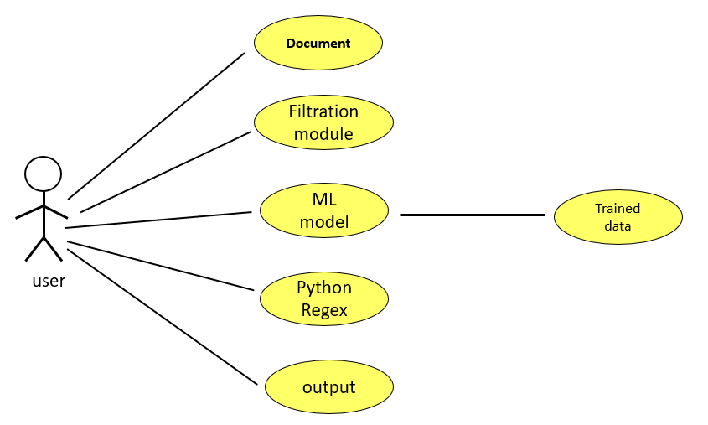
Fig 4.3: Use case Diagram
4.3.2 Class Diagram
Class diagram is a static diagram. It represents the static view of an application. Class diagram is not only used for visualizing, describing, and documenting different aspects of a system but also for constructing executable code of the software application.
Class diagram describes the attributes and operations of a class and also the constraints imposed on the system. The class diagrams are widely used in the modeling of object oriented systems because they are the only UML diagrams, which can be mapped directly with object-oriented languages.

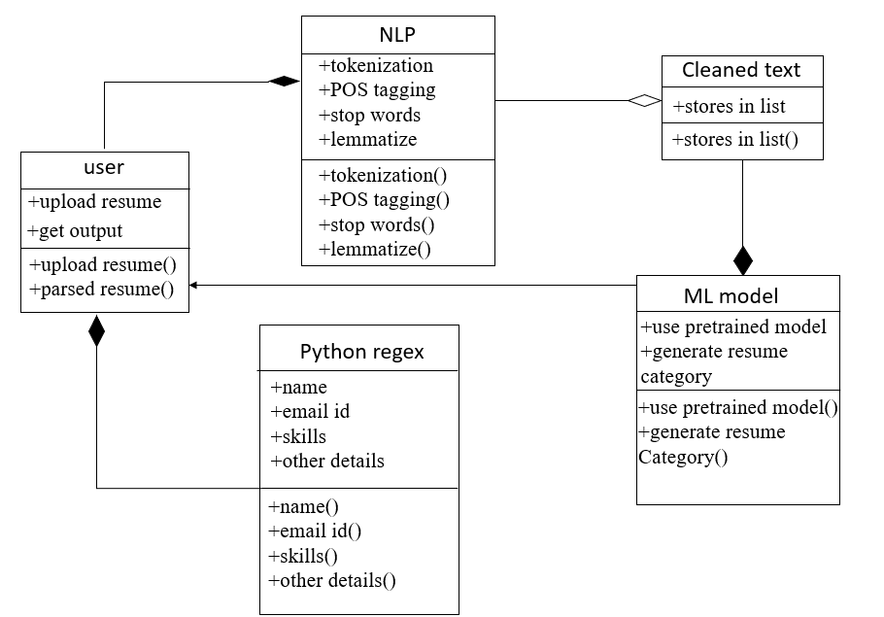

Fig 4.4: Class Diagram
4.3.3 Sequence Diagram
A sequence diagram simply depicts interaction between objects in a sequential order i.e., the order in which these interactions take place. We can also use the terms event diagrams or event scenarios to refer to a sequence diagram. Sequence diagrams describe how and in what order the objects in a system function. These diagrams are widely used by businessmen and software developers to document and understand requirements for new and existing systems.
It helps in envisioning several dynamic scenarios. In UML, the lifeline is represented by a vertical bar, whereas the message flow is represented by a vertical dotted line that extends across the bottom of the page. It incorporates the iterations as well as branching.
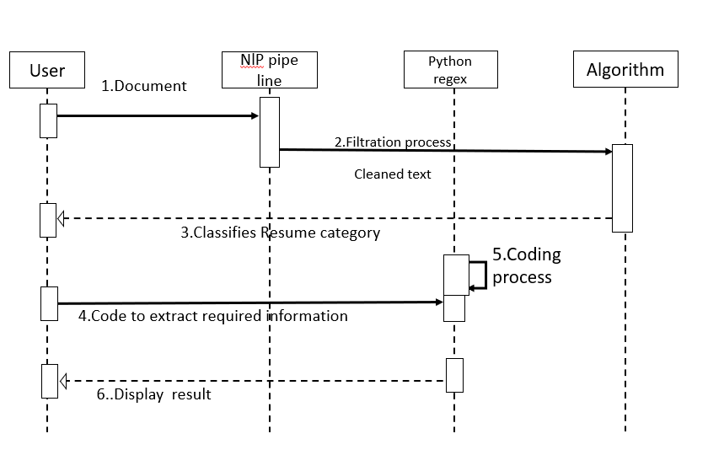
Fig 4.5: Sequence Diagram

4.3.4 Activity Diagram

An activity diagram illustrates the dynamic nature of a system by modeling the flow of management from activity to activity. An activity represents an operation on some category within the system that leads to an amendment within the state of the system. Typically, activity diagrams are accustomed model progress or business processes and internal operation. As a result of AN activity diagram may be a special quite state chart diagram, it uses a number of constant modeling conventions.

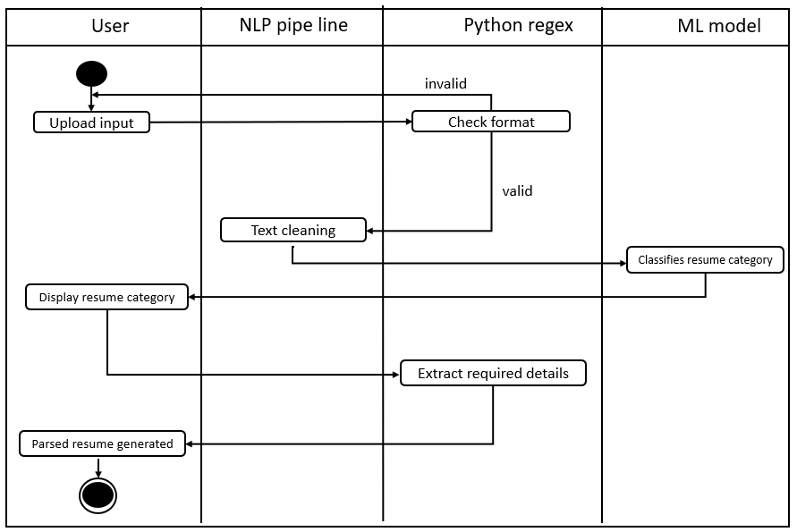

Fig 4.6: Activity Diagram

CHAPTER 5
IMPLEMENTATION

5.1 NLP pipe line
5.1.1 Tokenization
Tokenization is the task of chopping off a provided character sequence and a detailed document unit. It does away with certain characters like punctuation and the chopped units are further called tokens. It can be illustrated as follows:
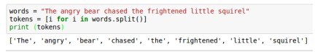
Tokens are usually referred to as terms or words, but sometimes fabricating a type/token distinction is essential. A specimen of an array of characters in a document that is assembled as a helpful acceptable unit for processing is called a token. Whereas, the group of tokens which consists of same character sequence is called type. And a type that is added to the dictionary of IR system is called term. We can completely differentiate a set of index terms from tokens. As an example we can say, they can be acceptable identifiers in taxonomy, but mostly in modern IR systems, they have a strong relation with tokens in the document. Nevertheless, as a substitute for being totally the tokens appearing in the document, they are mostly derived from them by various processes of normalization.

5.1.2 POS Tagging
we’ll look at each token and try to guess it’s part of speech whether it is a noun, a verb, an adjective and so on. Knowing the role of each word in the sentence will help us start to figure out what the sentence is talking about.
We can do this by feeding each word (and some extra words around it for context) into a pre-trained part-of-speech classification model:
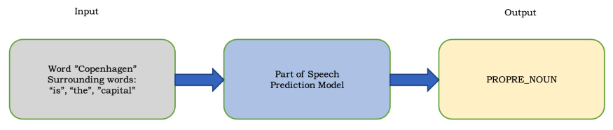
The part-of-speech model was originally trained by feeding it millions of English sentences with each word’s part of speech already tagged and having it learn to replicate that behavior. Keep in mind that the model is completely based on statistics — it doesn’t actually understand what the words mean in the same way that humans do. It just knows how to guess a part of speech based on similar sentences and words it has seen before.
After processing the whole sentence, we’ll have a result like this:

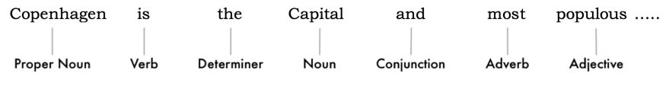

5.1.3 Stop words
we want to consider the importance of each word in the sentence. English has a lot of filler words that appear very frequently like “and”, “the”, and “a”. When doing statistics on text, these words introduce a lot of noise since they appear way more frequently than other words. Some NLP pipelines will flag them as stop words — that is, words that you might want to filter out before doing any statistical analysis.
Here’s how our sentence looks with the stop words grayed out:
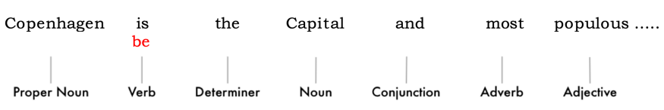
Stop words are usually identified by just by checking a hardcoded list of known stop words. But there’s no standard list of stop words that is appropriate for all applications. The list of words to ignore can vary depending on your application.
For example if you are building a rock band search engine, you want to make sure you don’t ignore the word “The”. Because not only does the word “The” appear in a lot of band names, there’s a famous 1980’s rock band called The The!

5.1.4 Lemmatization
English is also one of the languages where we can use various forms of base words. When working on the computer, it can understand that these words are used for the same concepts when there are multiple words in the sentences having the same base words. The process is what we call lemmatization in NLP.
It goes to the root level to find out the base form of all the available words. They have ordinary rules to handle the words, and most of us are unaware of them. We can also lemmatize verbs by finding their root, unconjugated form. So “I had two MacBooks” becomes “I [have] two [macbook].”

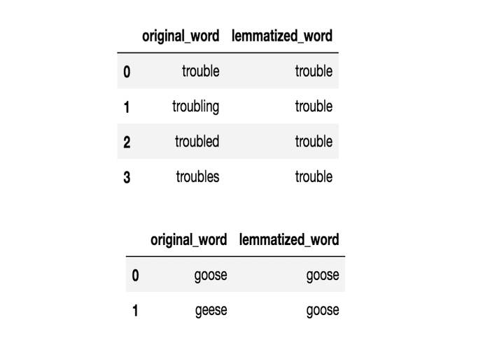

CHAPTER 6
SYSTEM TESTING
The purpose of testing is to discover errors. Testing is the process of trying to discover every conceivable fault or weakness in a work product. It provides a way to check the functionality of components, sub-assemblies, assemblies and/or a finished product. It is the process of exercising software with the intent of ensuring that the Software system meets its requirements and user expectations and does not fail in an unacceptable manner. There are various types of tests. Each test type addresses a specific testing requirement.

The test process is initiated by developing a comprehensive plan to test the general
functionality and special features on a variety of platform combinations. Strict quality control procedures are used.
The process verifies that the application meets the requirements specified in the system requirements document and is bug free. The following are the considerations used
to develop the framework from developing the testing methodologies.
6.1 Unit Testing
Unit testing involves the design of test cases that validate that the internal program
logic is functioning properly, and that program input produces valid outputs. All decision
branches and internal code flow should be validated. It is defined as the testing of individual software units of the application. It is done after the completion of an individual unit before integration. This is a structural testing, that relies on knowledge of its construction and is invasive.

Unit tests perform basic tests at component level and test a specific business process, application, and/or system configuration. Unit tests ensure that each unique path of a business process performs accurately to the documented specifications and contains clearly defined inputs and expected results.
6.2 Functional Testing
Functional Testing is a type of software testing that validates the software system against the functional requirements/specifications. The purpose of Functional tests is to test each function of the software application, by providing appropriate input, verifying the output against the Functional requirements. Functional testing mainly involves black box testing and it is not concerned about the source code of the application.

Functional testing is centered on the following items:
Valid Input : identified classes of valid input must be accepted.
Invalid Input : identified classes of invalid input must be rejected.
Functions : identified functions must be exercised.
Output : identified classes of application outputs must be exercised.
Systems/Procedures : interfacing systems or procedures must be invoked.

6.3 System Testing
System Testing is a type of software testing that is performed on a complete integrated system to evaluate the compliance of the system with the corresponding requirements. In system testing, integration testing passed components are taken as input. The goal of integration testing is to detect any irregularity between the units that are integrated together. System testing detects defects within both the integrated units and the whole system. The result of system testing is the observed behaviour of a component or a system when it is tested. System Testing is carried out on the whole system in the context of either system requirement specifications or functional requirement specifications or in the context of both.
6.4 Performance Testing

The Performance test ensures that the output be produced within the time limits,
and the time taken by the system for compiling, giving response to the users and request
being send to the system for to retrieve the results.

6.5 Integration Testing
Integration testing is the process of testing the interface between two software units or modules. It focuses on determining the correctness of the interface. The purpose of integration testing is to expose faults in the interaction between integrated units. Once all the modules have been unit tested, integration testing is performed.

Integration testing can be done by picking module by module. This can be done so that there should be proper sequence to be followed. And also, if you do not want to miss out on any integration scenarios then you have to follow the proper sequence.

To perform integration testing, testers use test drivers and stubs, which are dummy programs that act as substitutes for any missing modules and simulate data communications between modules for testing purposes.

6.6 Acceptance Testing
It is a formal testing according to user needs, requirements and business processes conducted to determine whether a system satisfies the acceptance criteria or not and to enable the users, customers, or other authorized entities to determine whether to accept the system or not.
User acceptance testing (UAT) is a type of testing, which is done by the customer before accepting the final product. Generally, UAT is done by the customer (domain expert) for their satisfaction, and check whether the application is working according to given business scenarios, real-time scenarios.
In this, we concentrate only on those features and scenarios which are regularly used by the customer or mostly user scenarios for the business or those scenarios which are used daily by the end-user or the customer.
6.7 Test cases

Test case Number | 1
Test case Name | Unit Test Case for uploading Resume by the user.
Feature to be tested | Resume upload
Description | When a resume is uploaded by the user, the python verifies the resume format.
Sample Input | Example.pdf,  Example.docx
Expected Output | The resume should be uploaded successfully without any errors and the uploaded resume should satisfy the mentioned format described above.
Actual Output | If the resume uploaded is invalid, the user do not get any output from the required resume parser application
Remarks | Successful.

Table 1 : Unit Test Case for Resume Upload

Test case Number | 2
Test case Name | Unit Test Case for Parsed Resume
Feature to be tested | Parsed Resume
Description | When a resume is uploaded by the user using the python code, the parsed resume should be generated after clicking the upload button.
Sample Input | Document for which parsed resume is to be Generated.
Expected Output | The important information is extracted from the particular selected resume taken from the dataset or in our internal storage  System.
Actual Output | If there is no resume selected, it do not shows any output to the user.
Remarks | Successful.

Table 2: Unit Test Case for Parsed Resume

Sr-no | Test Case Scenario | Expected results | Actual results
1 | Invalid Resume | Prompt for “please upload valid resume.” | Focus on Resume  format.
2 | No resume is selected | Do not show any output to the user | Focus on Parsed Resume.

Table 3 : Acceptance Test Case for extracting information.

Chapter 7
CODING
7.1 Importing packages
import numpy as np
import pandas as pd
import matplotlib.pyplot as plt
import nltk
import seaborn as sns
from nltk.stem import PorterStemmer
from nltk.corpus import stopwords
from nltk.stem import WordNetLemmatizer
import string
import re
!pip install Wordcloud
from wordcloud import WordCloud
from sklearn.preprocessing import LabelEncoder
from sklearn.model_selection import train_test_split
from sklearn.feature_extraction.text import TfidfVectorizer
from sklearn.naive_bayes import MultinomialNB
from sklearn.metrics import accuracy_score,classification_report,confusion_matrix
import pickle
import pytesseract
!pip install python-docx
import docx2txt
import nltk
from PyPDF2 import PdfFileReader, PdfFileWriter
7.2 Categories of resumes from dataset

df = pd.read_csv("./UpdatedResumeDataSet.csv")
df.head()
df.Category.unique()
df.Category.value_counts()

7.3 Graphical representation

import seaborn as sns
plt.figure(figsize=(15,15))
plt.xlabel("categories")
plt.ylabel("count")
sns.countplot(y='Category',data=df)
a = df.Category.value_counts()
b = df.Category.unique()
plt.figure(figsize=(15,15))
plt.pie(a, labels=b,autopct='%1.1f%%',shadow=True)
plt.show()

7.4 Filtration module (NLP pipe line)
from nltk.stem import PorterStemmer
from nltk.corpus import stopwords
from nltk.stem import WordNetLemmatizer
nltk.download("stopwords")
nltk.download("wordnet")
import string
k = string.punctuation
k
import re
lemma = WordNetLemmatizer()
corpus = []
for i in range(0,len(df)):
review = re.sub('http\S+\s*', ' ', df['Resume'][i]) # remove URLs
review = re.sub('RT|cc', ' ', review) # remove RT and cc
review = re.sub('#\S+', '', review) # remove hashtags
review = re.sub('@\S+', ' ', review) # remove mentions
review = re.sub('[%s]' % re.escape("""!"#$%&'()*+,-./:;<=>?@[\]^_`{|}~"""), ' ', review) # remove punctuations
review = re.sub(r'[^\x00-\x7f]',r' ', review)
review = re.sub('\s+', ' ', review) # remove extra whitespace
review = review.lower()
review = review.split()
review = [lemma.lemmatize(word) for word in review if not word in stopwords.words("english")]
review = ' '.join(review)
corpus.append(review)
df['Cleaned_resume'] = corpus
7.5 Train Test Split
from sklearn.model_selection import train_test_split
from sklearn.feature_extraction.text import TfidfVectorizer
text = df['Cleaned_resume']
target = df['Target']
tf = TfidfVectorizer()
data = tf.fit_transform(text).toarray()
data.shape
data
X_train,X_test,y_train,y_test = train_test_split(data,target,random_state=42, test_size=0.2)
X_train
X_test
y_train.head()
y_test.head()
print(X_train.shape)
print(y_train.shape)
from sklearn.naive_bayes import MultinomialNB
reg = MultinomialNB()
reg.fit(X_train,y_train)
from sklearn.metrics import accuracy_score,classification_report,confusion_matrix
y_train_pred = reg.predict(X_train)
print(accuracy_score(y_train,y_train_pred))
y_test_pred = reg.predict(X_test)
print(accuracy_score(y_test,y_test_pred))
print(confusion_matrix(y_test,y_test_pred))
print(classification_report(y_test,y_test_pred))
7.6 Saving the model
import pickle
with open("./model.pkl","wb") as f:
pickle.dump(reg,f)
m = pickle.load(open('./model.pkl','rb'))
7.7 Testing with Real Data
X_train
y_train
a = X_train[1]
a
reg.predict([a])
y_train
import pickle
with open('count.pkl','wb') as f:
pickle.dump(tf,f)
year = 2017
if (year % 400 == 0) and (year % 100 == 0):
print("{0} is a leap year".format(year))
elif (year % 4 ==0) and (year % 100 != 0):
print("{0} is a leap year".format(year))
import sklearn
print(sklearn.__version__)

7.8 Extracting text from document files
import pytesseract
from docx import Document
document = Document('./Akhil Muppa- Senior UI developer Profile.docx')
print(document.paragraphs)
sum1 = ''
for p in document.paragraphs:
sum1+=p.text

7.8 Conditions loop for clean the data for Test

sum1

lemma = WordNetLemmatizer()

p = []

review = re.sub('http\S+\s*', ' ',sum1) # remove URLs

review = re.sub('RT|cc', ' ', review) # remove RT and cc

review = re.sub('#\S+', '', review) # remove hashtags

review = re.sub('@\S+', ' ', review) # remove mentions

review = re.sub('[%s]' % re.escape("""!"#$%&'()*+,-./:;<=>?@[\]^_`{|}~"""), ' ', review) # remove punctuations

review = re.sub(r'[^\x00-\x7f]',r' ', review)

review = re.sub('\s+', ' ', review) # remove extra whitespace

review = review.lower()

review = review.split()

review = [lemma.lemmatize(word) for word in review if not word in stopwords.words("english")]

review = ' '.join(review)

p.append(review)

p[0]

l = tf.transform(p).toarray()
l
l.shape
X_train[0].shape
X_train[0]
sol = reg.predict(l)
sol
for i , j in dep.items():
if j == sol:
print(i)

7.9 Extracting required details by using python regex
import re
regu =re.findall(r'[\+\(]?[1-9][0-9 .\-\(\)]{8,}[0-9]',sum1)
regu
emails = re.findall(r"[a-z0-9\.\-+_]+@[a-z0-9\.\-+_]+\.[a-z]+",sum1)
print(emails)
results = {"Mobile_Number ": regu ,
"Mail_id" : emails}
results
import docx2txt
import nltk
nltk.download('stopwords')
# you may read the database from a csv file or some other database
SKILLS_DB = []
ch = ['c','c++','java','.NET c#','python','ruby','php','html','css','javascript','node js','react js','django','flask','apache', 'hadoop','big data','data science','numpy','pandas','machine learning','deep learning','statistics','nlp','natural language processing','open cv','compter vision','devops','aws','azure','microsoft azure','google cloud','rest api','graphql','react','react native', 'sql','postgresql','git','redis','jira','selenium','jquery','bootstrap','mongodb']
for i in ch:
SKILLS_DB.append(i.lower())
def extract_text_from_docx(docx_path):
txt = docx2txt.process(docx_path)
if txt:
return txt.replace('\t', ' ')
return Non
def extract_skills(input_text):
input_text = input_text.lower()
stop_words = set(nltk.corpus.stopwords.words('english'))
word_tokens = nltk.tokenize.word_tokenize(input_text)
# remove the stop words
filtered_tokens = [w for w in word_tokens if w not in stop_words]
# remove the punctuation
filtered_tokens = [w for w in word_tokens if w.isalpha()]
# generate bigrams and trigrams (such as artificial intelligence)
bigrams_trigrams = list(map(' '.join, nltk.everygrams(filtered_tokens, 2, 3)))
# we create a set to keep the results in.
found_skills = set()
# we search for each token in our skills database
for token in filtered_tokens:
if token.lower() in SKILLS_DB:
found_skills.add(token)
# we search for each bigram and trigram in our skills database
for ngram in bigrams_trigrams:
if ngram.lower() in SKILLS_DB:
found_skills.add(ngram)
return found_skills
if __name__ == '__main__':
text = extract_text_from_docx('./senior-java-developer-1548174801.docx')
skills = extract_skills(text)
print(skills)
import docx2txt
import docx2txt
import nltk
nltk.download('punkt')
nltk.download('averaged_perceptron_tagger')
nltk.download('maxent_ne_chunker')
nltk.download('words')
import spacy
from spacy.matcher import Matcher
# load pre-trained model
nlp = spacy.load('en_core_web_sm')
# initialize matcher with a vocab
matcher = Matcher(nlp.vocab)
def extract_name(resume_text):
nlp_text = nlp(resume_text)
# First name and Last name are always Proper Nouns
pattern = [{'POS': 'PROPN'}, {'POS': 'PROPN'}]
matcher.add('NAME', [pattern]
matches = matcher(nlp_text)

for match_id, start, end in matches:
span = nlp_text[start:end]
return span.text
extract_name(sum1)

7.10 Complete loop
import pickle
with open("./model.pkl","wb") as f:
pickle.dump(reg,f)
model = pickle.load(open('./model.pkl','rb'))
SKILLS_DB = []
ch = ['c','c++','java','.NET c#','python','ruby','php','html','css','javascript','node js','react js','django','flask','apache','hadoop','bigdata','datascience','numpy','pandas','machine learning','deep learning','statistics','nlp','natural language processing''open cv','compter vision','devops','aws','azure','microsoft azure','google cloud','rest api','graphql','react','react native','sql','postgresql','git','redis','jira','selenium','jquery','bootstrap','mongodb','UI KIT','Swift','github','xcode']
for i in ch:
SKILLS_DB.append(i.lower())

7.12 For Docx and PDF files

def complete_logic(resume1):

from PyPDF2 import PdfFileReader, PdfFileWriter

import fitz

resume=''

from docx import Document

if resume1.endswith('.docx'):

resume = resume1

# Cleaning Incoming Data

resume_text = Document(resume)

complete_text = ''

for p in resume_text.paragraphs:

complete_text+=p.text

lemma = WordNetLemmatizer()

p = []

review = re.sub('http\S+\s*', ' ',complete_text) # remove URLs

review = re.sub('RT|cc', ' ', review) # remove RT and cc

review = re.sub('#\S+', '', review) # remove hashtags

review = re.sub('@\S+', ' ', review) # remove mentions

review = re.sub('[%s]' % re.escape("""!"#$%&'()*+,-./:;<=>?@[\]^_`{|}~"""), ' ', review) # remove punctuations

review = re.sub(r'[^\x00-\x7f]',r' ', review)

review = re.sub('\s+', ' ', review) # remove extra whitespace

review = review.lower()

review = review.split()

review = [lemma.lemmatize(word) for word in review if not word in stopwords.words("english")]

review = ' '.join(review)

p.append(review)

l = tf.transform(p).toarray()

# Loading Model

sol = model.predict(l)

for i , j in dep.items():

if j == sol:

print("Category of Resume belongs to = ",i)

regu =re.findall(r'[\+\(]?[1-9][0-9 .\-\(\)]{8,}[0-9]',complete_text)

print('------------------*--------------------')

print('Mobile Number = ',regu)

emails = re.findall(r"[a-z0-9\.\-+_]+@[a-z0-9\.\-+_]+\.[a-z]+",complete_text)

print('-------------------*--------------------')

print("Email = ",emails)

print("-------------------*-----------------------")

a = re.findall(r"(\d+(?:\.\d+)?).?\s?year.?",complete_text)

print("Total years of experience = ",a[0],'years')

print('-------------------*------------------------')

## Extract name

nlp = spacy.load('en_core_web_sm')

# initialize matcher with a vocab

matcher = Matcher(nlp.vocab)

nlp_text = nlp(complete_text)

# First name and Last name are always Proper Nouns

pattern = [{'POS': 'PROPN'}, {'POS': 'PROPN'}]

matcher.add('NAME', [pattern])

matches = matcher(nlp_text)

for match_id, start, end in matches:

span = nlp_text[start:end]

print("Name = ",span.text)

print('--------------------*-------------')

# Extracting skills

import docx2txt

sk = docx2txt.process(resume)

if sk:

a4 = sk.replace('\t',' ')

input_text = a4.lower()

stop_words = set(nltk.corpus.stopwords.words('english'))

word_tokens = nltk.tokenize.word_tokenize(input_text)

# remove the stop words

filtered_tokens = [w for w in word_tokens if w not in stop_words]

# remove the punctuation

filtered_tokens = [w for w in word_tokens if w.isalpha()]

# generate bigrams and trigrams (such as artificial intelligence)

bigrams_trigrams = list(map(' '.join, nltk.everygrams(filtered_tokens, 2, 3)))

# we create a set to keep the results in.

found_skills = set()

# we search for each token in our skills database

for token in filtered_tokens:

if token.lower() in SKILLS_DB:

found_skills.add(token)

# we search for each bigram and trigram in our skills database

for ngram in bigrams_trigrams:

if ngram.lower() in SKILLS_DB:

found_skills.add(ngram)

print("Skills = ",found_skills)

elif resume1.endswith('.pdf'):

complete_text=''

with fitz.open(resume1) as doc:

for page in doc:

complete_text += page.get_text()

# Cleaning Incoming Data

lemma = WordNetLemmatizer()

p = []

review = re.sub('http\S+\s*', ' ',complete_text) # remove URLs

review = re.sub('RT|cc', ' ', review) # remove RT and cc

review = re.sub('#\S+', '', review) # remove hashtags

review = re.sub('@\S+', ' ', review) # remove mentions

review = re.sub('[%s]' % re.escape("""!"#$%&'()*+,-./:;<=>?@[\]^_`{|}~"""), ' ', review) # remove punctuations

review = re.sub(r'[^\x00-\x7f]',r' ', review)

review = re.sub('\s+', ' ', review) # remove extra whitespace

review = review.lower()

review = review.split()

review = [lemma.lemmatize(word) for word in review if not word in stopwords.words("english")]

review = ' '.join(review)

p.append(review)

l = tf.transform(p).toarray()

# Loading Model

sol = model.predict(l)

for i , j in dep.items():

if j == sol:

print("Category of Resume belongs to = ",i)

regu =re.findall(r'[\+\(]?[1-9][0-9 .\-\(\)]{8,}[0-9]',complete_text)

print('------------------*--------------------')

print('Mobile Number = ',regu)

emails = re.findall(r"[a-z0-9\.\-+_]+@[a-z0-9\.\-+_]+\.[a-z]+",complete_text)

print('-------------------*--------------------')

print("Email = ",emails)

print("-------------------*-----------------------")

a = re.findall(r"(\d+(?:\.\d+)?).?\s?year.?",complete_text)

print("Total years of experience = ",a[0],'years')

print('-------------------*------------------------')

## Extract name

nlp = spacy.load('en_core_web_sm')

# initialize matcher with a vocab

matcher = Matcher(nlp.vocab)

nlp_text = nlp(complete_text)

# First name and Last name are always Proper Nouns

pattern = [{'POS': 'PROPN'}, {'POS': 'PROPN'}]

matcher.add('NAME', [pattern])

matches = matcher(nlp_text

for match_id, start, end in matches:

span = nlp_text[start:end]

print("Name = ",span.text)

print('--------------------*-------------')

# Extracting skills

input_text = complete_text.lower()

stop_words = set(nltk.corpus.stopwords.words('english'))

word_tokens = nltk.tokenize.word_tokenize(input_text)

# remove the stop words

filtered_tokens = [w for w in word_tokens if w not in stop_words]

# remove the punctuation

filtered_tokens = [w for w in word_tokens if w.isalpha()]

# generate bigrams and trigrams (such as artificial intelligence)

bigrams_trigrams = list(map(' '.join, nltk.everygrams(filtered_tokens, 2, 3)))

# we create a set to keep the results in.

found_skills = set()

# we search for each token in our skills

for token in filtered_tokens:

if token.lower() in SKILLS_DB:

found_skills.add(token)

# we search for each bigram and trigram in our skills

for ngram in bigrams_trigrams:

if ngram.lower() in SKILLS_DB:

found_skills.add(ngram)

print("Skills = ",found_skills)

CHAPTER 8

OUTPUT SCREENS

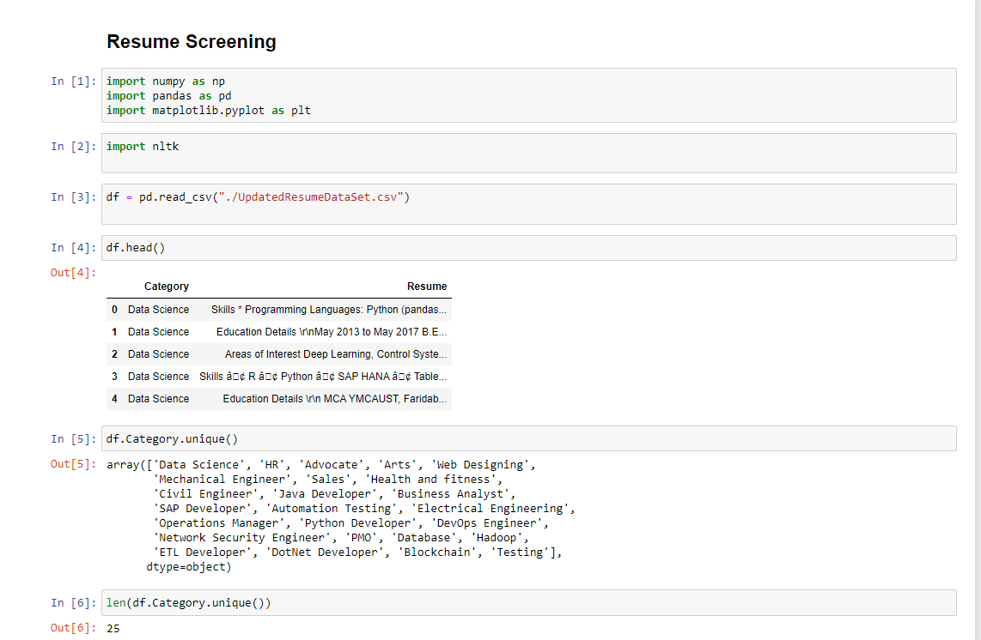

Fig 8.1 Jupyter Interface

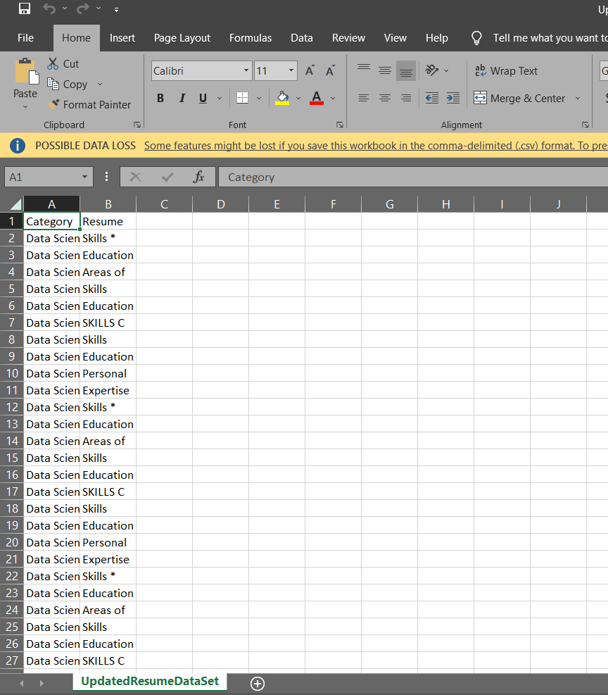
Fig 8.2 Resume Data set

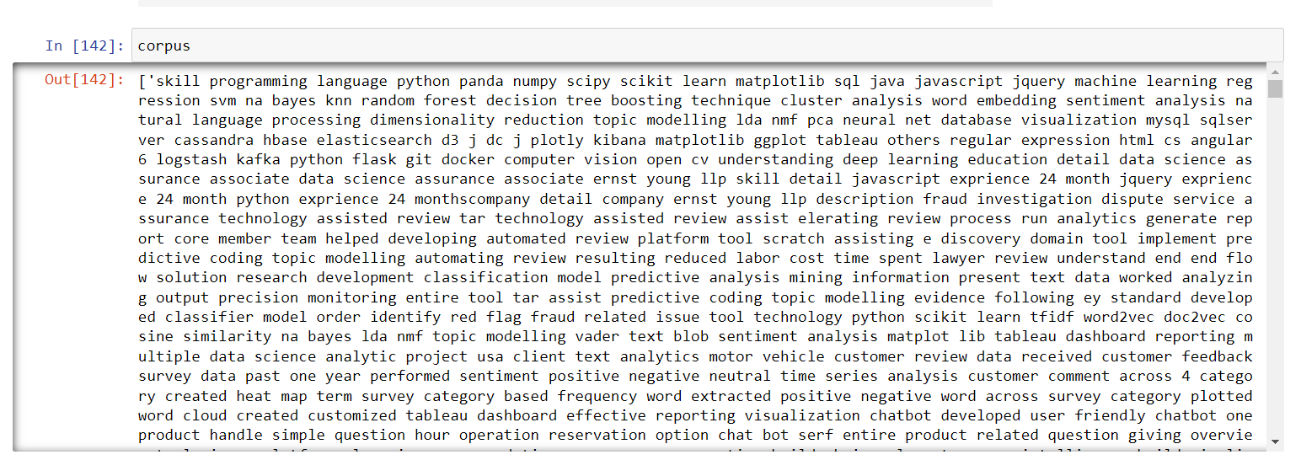
Fig 8.3 Corpus data

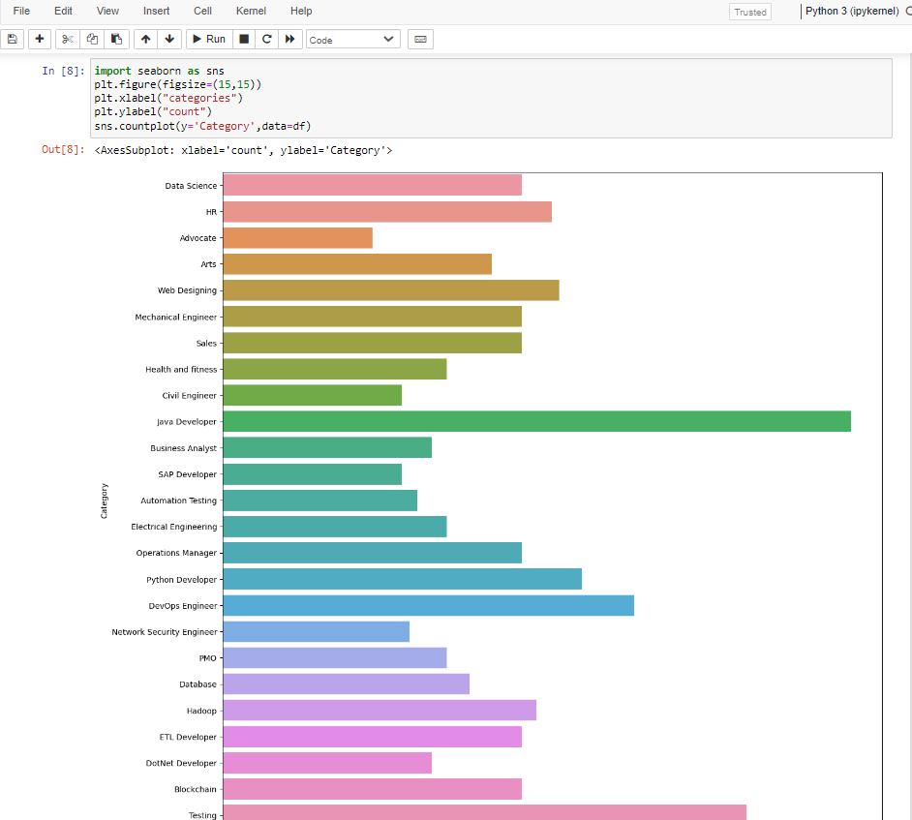

Fig 8.3 Graphical representation of categories from dataset
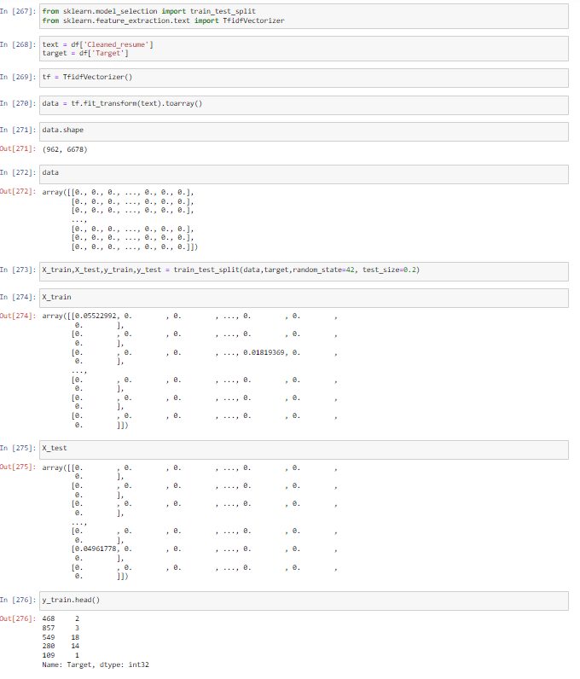
Fig 8.4 Train Test Split

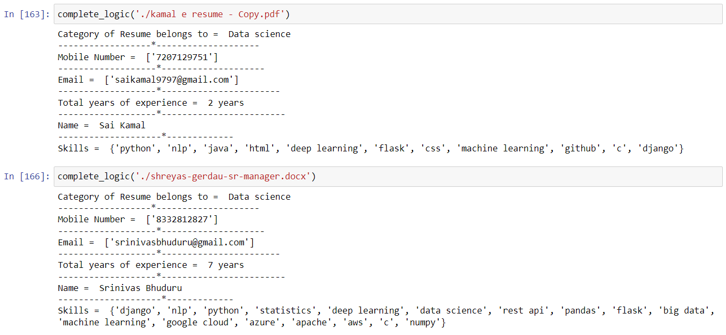

Fig 8.5 Parsed resume is generated
CHAPTER 9
CONCLUSION

A normal resume is a compilation of information about a person's work experience, academic background, qualifications, and personal details. These elements might be present in a variety of ways or not at all. It's difficult to keep up with the jargon used in resumes. A resume is made up of corporate names, institutions, degrees, and other information that can be written in a variety of ways. It will take time to review all the resume by an individual.

Machine works faster than human and their accuracy to do any task was also good. Therefore, I have made a system which includes machine learning that extract the important information from resumes within a minute or less than a minute. The hiring individual can use this system for hiring any individual. From this project we conclude that with the help of ML models and python, we developed a resume parser application that can extract the important information from the resume.It is more constructive for companies to hire the candidates by selecting the main objects from their resumes which are derived by using this resume parsing application.
Our approach is to make the work of companies and candidates easier and effective. Basically our aim is to ease the recruitment process. The process will provide the quality of applicants for the companies. The unfair and discriminatory practice in the process will be dampened.

CHAPTER 10
FUTURE ENHANCEMENT

The main future scope of our project is to parse resumes from different applications and websites like LinkedIn, GitHub, Naukri.com, etc. In future, this system can be made more versatile in which wide ranges of psychometric tests will be added. As a future work, we can enlarge the resume dataset and improve the performance of the proposed system. Further, future study will include a more in-depth examination of certain techniques, further research on other libraries, and new approaches to explore different methods.

CHAPTER 11
REFERENCES
- C, B. P., 2020. towardsai. [Online]
Available at: https://towardsai.net/p/nlp/natural-language-processing-concepts-andworkflow-48083d2e3ce7 [Accessed 2022].
- Agrawal , R., 2021. analyticsvidhya. [Online]
Available at: https://www.analyticsvidhya.com/blog/2021/06/must-knowntechniques-for-text-preprocessing-innlp/#:~:text=Text%20preprocessing%20is%20a%20method,text%20in%20a%20diff erent%20case. [Accessed 2022].
- Bhatia, V., Rawat, P., Kumar, A. & Shah, R. R., 2019. End-to-End Resume Parsing and Finding Candidates for a Job Description using BERT. arxiv.
- chavan, J., 2020. medium. [Online]
Available at: https://medium.com/@jeevanchavan143/nlp-tokenization-stemminglemmatization-bag-of-words-tf-idf-pos-7650f83c60be [Accessed 2022].
- Chen, J., Gao, . L. & Tang, Z., 2016. Information Extraction from Resume Documents in PDF. researchgate.
- Kopparapu, S. . K., 2015. Automatic Extraction of Usable Information from Unstructured Resumes to Aid Search. ieeexplore.
- Nguyen, V. V., Pham, V. . L. & Vu, N. . S., 2018. Study of Information Extraction in Resume. semanticscholar.
- D., 2021. analyticsvidhya. [Online]
Available at: https://www.analyticsvidhya.com/blog/2021/06/text-preprocessing-innlp-with-python-codes/ [Accessed 2022].
- geeksforgeeks, 2018. geeksforgeeks. [Online]
Available at: https://www.geeksforgeeks.org/unified-modeling-language-umlsequence-diagrams/ [Accessed 2022].

